Adding User / Advisor Access rights / Emails

- Stakeholder user – Added inside the stakeholder
  - The person who has access to the account for the user
  - Does not automatically get link for e-sign
  - Can add a ‘CC’ – this email will be copied on all emails sent to the Investor (across all funds)

- Advisor email – added inside the Folio in a particular fund
  - Need to set up a commitment and then add Advisor for the same.
  - Gets a link for all emails sent for that ‘Folio’
  - Does not get link for e-sign
  - Same advisor may be added to multiple users

- Signatory emails
  - Added in KYC; auto copied into the commitment
  - The e-sign link for the Agreement is sent to this email address

- Adding Advisor as CC but not sending separate email to the advisor
  - Add Advisor to the folio
  - Set up stakeholder user with advisor as CC
  - Under the stakeholder, the advisor will be showing up – edit and uncheck the box for ‘Email enabled’. Keep Approved as checked
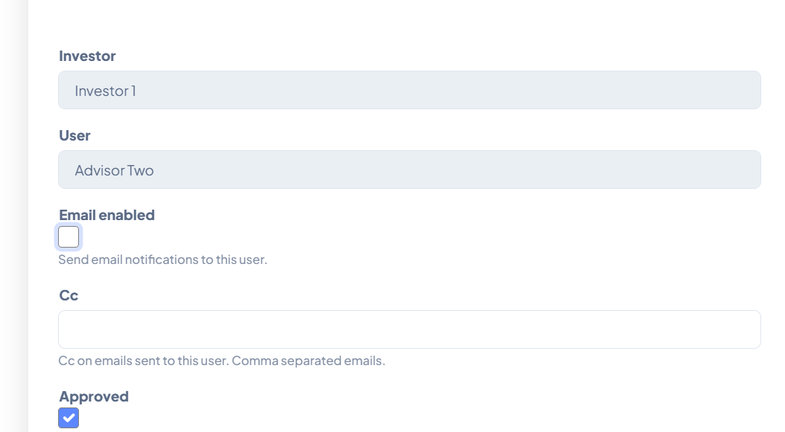

What this does:
- Creates 2 users for the Investors – each of them will be able to edit the KYC.
- On an ongoing basis, the advisor will be able to access details only for this fund and not other funds where same investor may be invested
- Adds the advisor as CC on all emails to the investor
- Disables separate emails for the advisor so they will only get 1 email
To be mindful: In case this investor will have commitments in other funds where the same advisor is not applicable, then will need to remove the advisor from the Stakeholder User ‘CC’

- Adding Advisor as ‘To’ and Investor as ‘cc’ and no separate emails.
  - Add Advisor to the folio
  - Add Investor email to the stakeholder user but disable the email by unchecking the box for ‘Email Enabled’. Keep only Approved as checked
This will allow platform access to the Investor but not send any direct emails to them.

  - Under the stakeholder, the advisor will be showing up – edit and add the investor email id as ‘cc’. Keep Approved and Email Enabled as checked

What this does:
- Creates 2 users for the Investors – each of them will be able to edit the KYC.
- On an ongoing basis, the advisor will be able to access details only for this fund and not other funds where same investor may be invested
- Disables separate emails for the investor
- Adds the investor as CC on the emails to the advisor for this investor only.
To be mindful: Post onboarding or adding additional funds, remember to enable the email to the Investors, else they will not get direct emails.

